**BUGS REPORT**

1. **Title of the page is showing incorrect spelling**

Steps to reproduce:  
1. Hit the url: <https://qainterview.pythonanywhere.com/>  
2. Verify the Title of the page  
  
Actual Result: Title of the page is showing: Factoriall

Expected Result: Title of the page should be: Factorial!  
  
Please refer the below screenshot for the same:  
  
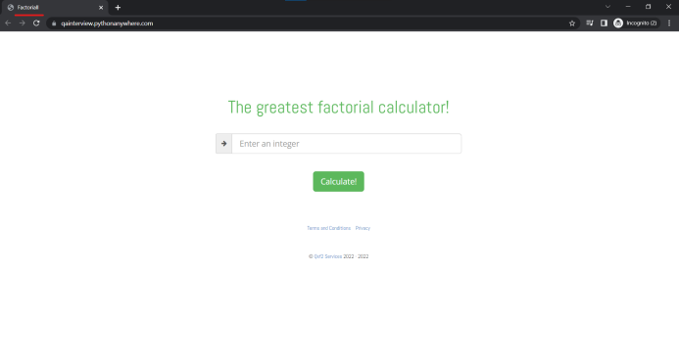

1. **Favicon icon is not present**

Steps to reproduce:  
1. Hit the url: <https://qainterview.pythonanywhere.com/>  
2. Verify the Title of the page  
  
Actual Result: Favicon icon is not present

Expected Result: Favicon icon should be present  
  
Please refer the below screenshot for the same:

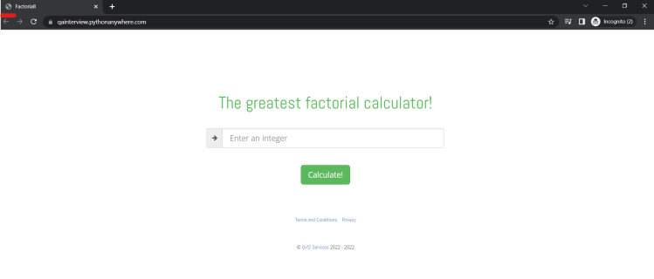

1. **After integer value 170, its factorial value is showing Infinity**  
     
   Steps to reproduce:  
   1. Hit the url: <https://qainterview.pythonanywhere.com/>

2. Enter integer value as greater than 170  
 3. Click on Calculate button  
  
Actual Result: Factorial value is showing Infinity

Expected Result: Factorial value should be calculated and display the correct results  
  
Please refer the below screenshot for the same:  
  
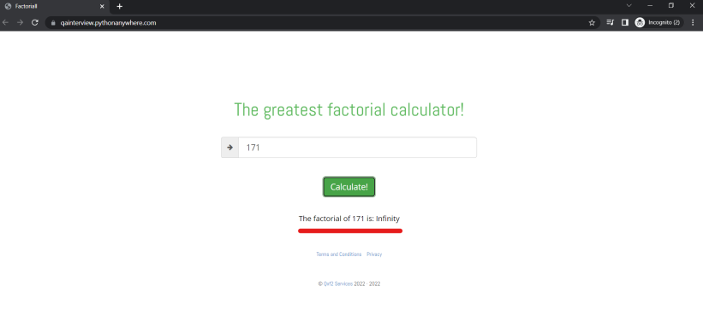

1. **Console Error – 500 Internal Server Error is displayed for integer greater than 992**Steps to reproduce:  
   1. Hit the url: <https://qainterview.pythonanywhere.com/>  
   2. Enter integer value as greater than 992  
   3. Click on Calculate button  
   4. Verify Console  
     
   Actual Result: 500 Internal Server Error is displayed   
   Expected Result: Factorial value should be calculated and display the correct results  
     
   Please refer the below screenshot for the same:  
     
   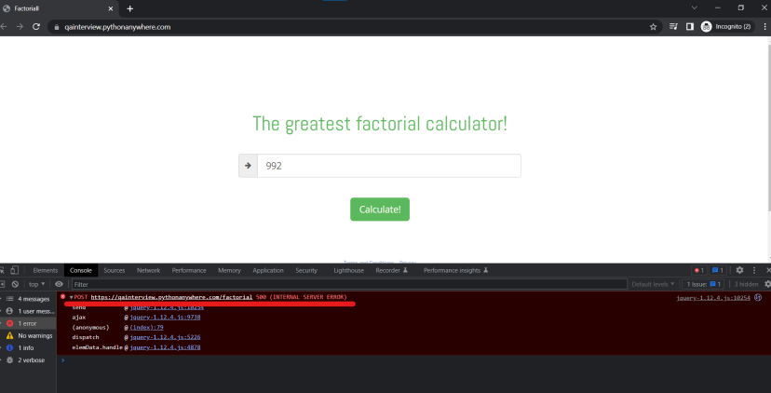
2. **Arrow icon present is of no use**Steps to reproduce:  
   1. Hit the url: <https://qainterview.pythonanywhere.com/>

2. Enter integer value as greater than 170  
 3. Click on Arrow icon  
  
Observation: Arrow icon is of no user, clicking on arrow icon does nothing  
Expected Result: Arrow icon should be removed  
  
Please refer the below screenshot for the same:  
  
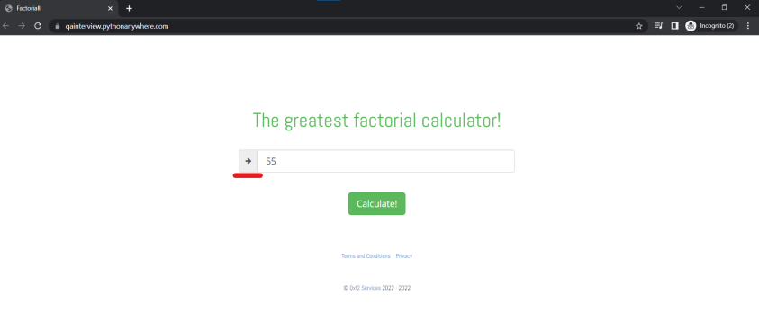

1. **Validation message is not appearing for decimal input if 00.. is added after decimal point and console error – 500 Internal Server error appears**Steps to reproduce:  
   1. Hit the url: <https://qainterview.pythonanywhere.com/>  
   2. Enter integer value as 1.00, 2.00 ,3.0000 etc  
   3. Click on Calculate button  
     
   Actual Result: Validation message is not appearing for decimal input if 00.. is added after decimal point and console error – 500 Internal Server error appears  
   Expected Result: Validation message should appear as ‘Please enter an integer’ and console error should not appear  
     
   Please refer the below screenshot for the same:  
   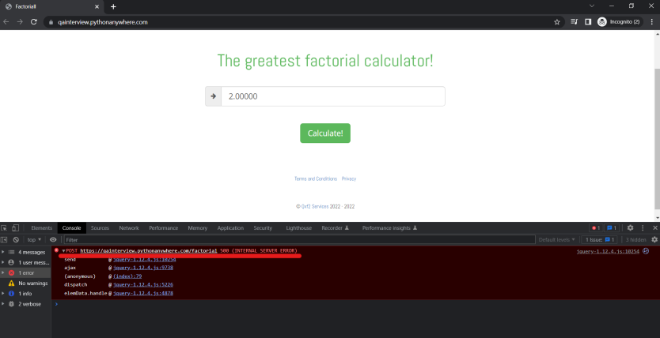

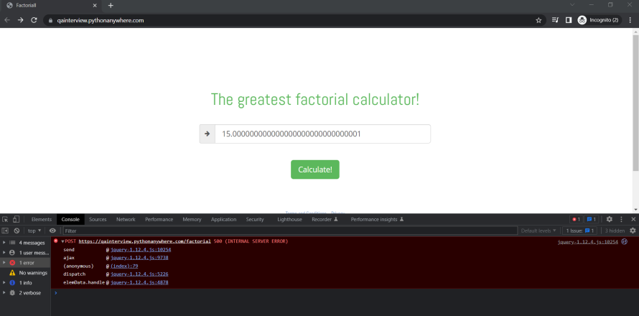

1. **When invalid value is entered, previously factorial output should be cleared and validation message should be thrown**  
     
   Steps to reproduce:  
   1. Hit the url: <https://qainterview.pythonanywhere.com/>  
   2. Enter valid integer value as 4   
   3. Click on Calculate button  
   4. Enter invalid value as 10.0  
   5. Click on Calculate button  
     
   Actual Result: Validation message is not appearing for invalid value and previously calculated factorial is still displayed  
   Expected Result: Validation message should appear as ‘Please enter an integer’ and previously factorial output should be cleared  
     
   Please refer the below screenshot for the same:  
   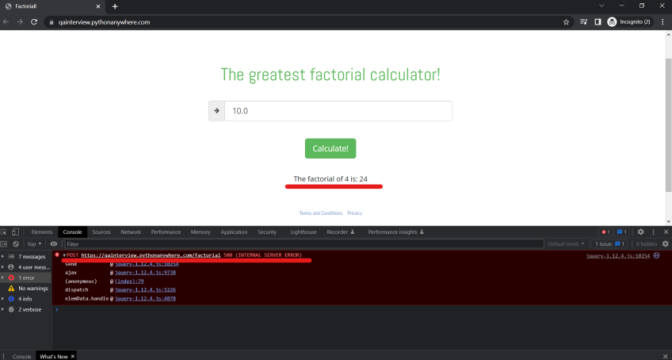
2. **Negative value should show validation message**Steps to reproduce:  
   1. Hit the url: <https://qainterview.pythonanywhere.com/>  
   2. Enter invalid negative integer value as -4   
   3. Click on Calculate button   
     
   Actual Result: Console error 500- Internal Server Error is displayed  
   Expected Result: Validation message should appear as ‘Please enter a positive integer’ and console error should not appear  
     
   Note: We can change placeholder of the input field to : Enter a positive integer / whole number  
     
   Please refer the below screenshot for the same:  
    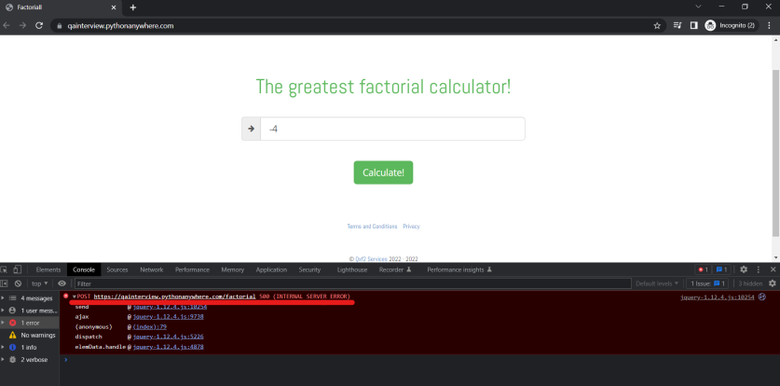
3. Console is showing input/output value and result message  
     
   Steps to reproduce:  
   1. Hit the url: <https://qainterview.pythonanywhere.com/>  
   2. Enter valid integer value as 4   
   3. Click on Calculate button   
   4. Verify Console message  
     
   Observation: Console is displaying showing input/output value and result message  
   Expected Result: Input/output results should not be displayed  
     
   Please refer the below screenshot for the same:  
     
   